**Kindergarten Summer Practice Ideas**

If you are new to Kindergarten, here are things to do as you get ready for the year.

1. Practice writing your first and last name.
2. Practice saying your phone number and address.
3. Read stories with a grown-up and talk about what is happening.
4. If you have access to a computer or tablet, try some activities on [www.starfall.com](http://www.starfall.com) or [www.abcya.com](http://www.abcya.com).
5. Practice counting to 20 or even higher. Maybe try counting backward from 10 or 20.
6. Practice cutting straight and curvy lines with some kid scissors.
7. Practice buttoning your clothes, tying your shoes, and opening your snack containers and bottles.

As you head to first grade, be sure to spend a little time reviewing the things we’ve been working on this year. Listed here are some ideas for you to do for practice.

**Ideas for math practice:**

1. Use any of the pages we did not complete in the math workbook for some extra practice. You can also use any of the optional extra practice books that were sent home.
2. Use a hundred grid to practice counting by ones, fives, and tens. Maybe even try counting by twos.
3. Use ten frames, number bonds, and counters to practice adding and subtracting facts to 20.
4. Play some of the fact practice games you’ve learned during the year. You may even want to use some of the game boards that you saved.
5. If you have access to a computer or tablet, try some activities on [www.abcya.com](http://www.abcya.com) or [www.gregtangmath.com](http://www.gregtangmath.com). On the Greg Tang site, a few great games to explore are Ten Frame Mania, How Much How Many, and Num Tanga.

**Ideas for writing practice:**

1. Draw a picture and write a story with a beginning, middle, and ending sentence. Use pages that are left in your writing journal or make a new journal of your own.
2. Write a note or a postcard to a friend or family member.
3. Write out the grocery list and help your family when you go grocery shopping.
4. Create a scavenger hunt to play with your friends or family. Write your clues on cards and then put them in place leading to the final stop. Have fun watching the players look for a surprise you’ve hidden. It could be a drawing you made, a craft you created, a game to play, or even a little treat if you ask permission!
5. Use your extra handwriting book or the alphabet pages at the end of your Reading Horizons books to practice making your letters properly. The more you practice, the faster and easier it gets!

**Ideas for reading practice:**

1. Be sure to read something every day. Don’t forget about Linden’s Summer Reading Challenge! Use the Bingo board that was sent home. Return your completed list to Linden next year.
2. Join the Bucks County Free Library’s Summer Quest. Check out the activities at <http://buckscounty.beanstack.org/>. It starts on June 19!
3. Use the Reading Horizons Discovery Clubhouse program that we’ve been working with this year. It is no longer supported as an app, but you can access it on a computer or tablet at [RHdiscovery.com](https://nam02.safelinks.protection.outlook.com/?url=http%3A%2F%2Frhdiscovery.com%2F&data=04%7C01%7CECORRIGA%40CBSD.ORG%7C5f58f9055198488e130a08d921074b63%7Caa0b488ffc9e4185a5e3384220df23ca%7C0%7C0%7C637577137483910429%7CUnknown%7CTWFpbGZsb3d8eyJWIjoiMC4wLjAwMDAiLCJQIjoiV2luMzIiLCJBTiI6Ik1haWwiLCJXVCI6Mn0%3D%7C1000&sdata=Us184nsTUAwryPeW5ymW7Qx7HheThev1r1T0tl7TW1Y%3D&reserved=0). Your child’s current Site ID (Lindenelementary) and User ID (your child’s first name initial and first four letter of your last name) will remain in place until the district resets the lists for next year. That should not occur until mid-August.
4. Read on Kids A-Z at <https://www.raz-kids.com/>. The teacher username is still ecorrigan2 and the current passwords should work until mid-August as well.
5. Practice slides and basic words using the patterns we’ve learned in Reading Horizons this year. You can use your workbooks that we’ve completed to look for examples.

**Ideas for sight word practice:**

1. Chant the spelling of each word. Do it “volcano style” by starting at the floor and rising each time you add a letter. At the top, jump and “explode” by shouting the word.”

**Ex:** went- W-E-N-T – went

1. Sing the spelling of each word like an opera singer.
2. Spell the word as if you were a tiger, lion, or bear.
3. “Play baseball” by pretending to be the batter and hit each letter out of the park with your imaginary bat.
4. Write your words on cards or use your cards from your word ring. Make 6 piles of cards, one for each of the sides of a dice. Use the “Roll a Word” graph and one of the dice from the grab bag. Roll the dice and say/spell the word on the card from that pile. Color in a block above that number on the graph. The game is over when one of the columns is full.
5. Create some “Spelling Spirals” for your words.
6. Do “Pyramid Spelling” for your words.
7. Have an adult hang cards with your words from the ceiling and put some on cards on the floor. Then jump up or bend down to hit and say the words like a sight word obstacle course.
8. “Rainbow write” your words. Write a word all the way through in one color. Then pick another color and trace it again. Pick a third color and repeat it once more.
9. Put some rice into a long, shallow container. Use your finger to spell the letters of a word. Shake the container back and forth gently to erase the word and do the next one.
10. Ask an adult to squirt some shaving cream onto your table and spread it out into a thin layer. (You may want to do this on Saran wrap or a tray that’s easily washable. Do NOT do this on a surface that could be damaged…) Then spell each word in the shaving cream. Erase for space for a new word by running your hand over it to make it all smooth again.
11. Play “Pop” using your popcorn box and the cards from your word ring. You can play against a partner or by yourself. If you play against a partner, take turns picking a card from the box. If you can read it, you keep it. If not, put it back for another try later. If the “pop” card appears, put all your cards back in the box. The person with the most cards at the end is the winner. If you are playing by yourself, see how many cards you can read before you are popped!

This can also be used as a spelling practice if you play with a partner. In that case, have your partner pull a card without showing you and tell you the word. If you can spell it, you get the card. If not, it goes back in the box for another try. Then it’s your partner’s turn and you read a word for them. If a pop comes up, the person who is supposed to spell the word is “popped” and has to put their cards back.

Kindergarten Most Common Words for Mastery:

a, and, are, as, at

be, by

for, from

had, have, he, his

I, in, is, it

of, on, one, or

that, the, they, this, to

was, with, word

you

Additional sight words practiced this year as part of Kid Writing:

like, said, saw, then, there, went, were, when, then, your, me, she, see

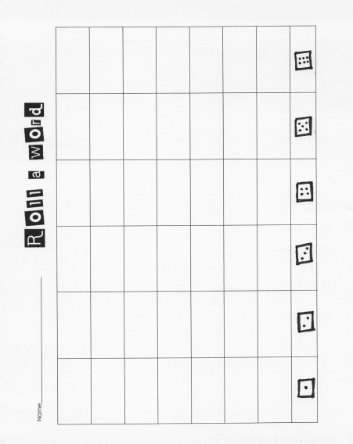

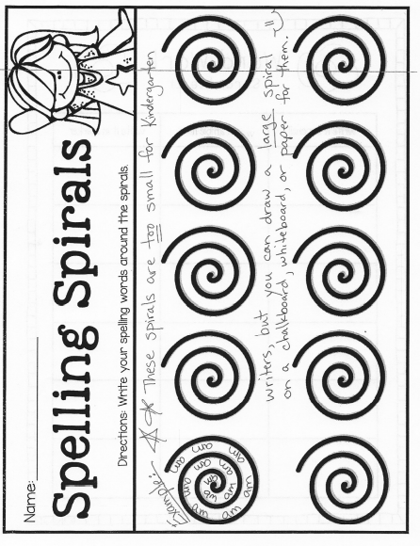Samples to do on a white board or piece of paper:

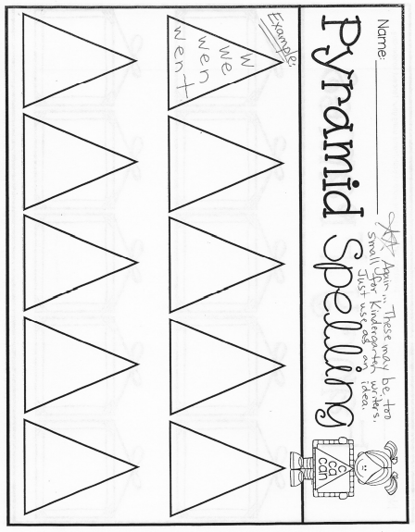

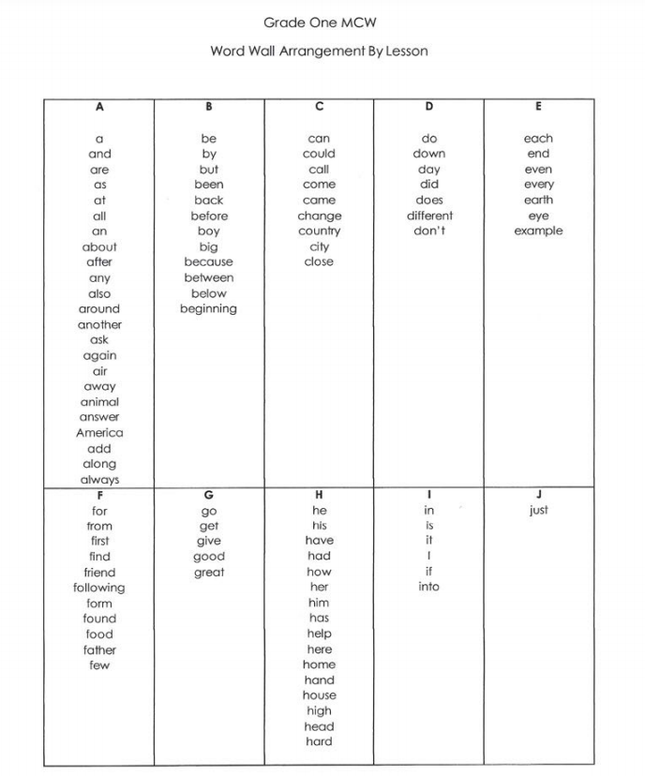If you’d like to challenge yourself with words that are part of the first-grade list, that’s wonderful! Use this chart:

